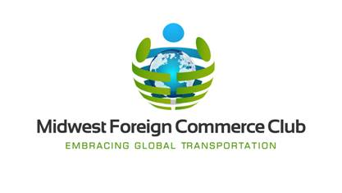

Midwest Foreign Commerce Club Board

Chairman: Mike Gismondi
President: Bob Reinecke
Vice President: Steve Nothdurft
Treasurer: Bill Laird
Secretary: Jennifer Crotty

Board of Governors

Mary Alice Armstrong
Dan Connerty
Carrie Dollear
Kris Redmond
Peter Terkildsen
Gavin Thomson

